AATC_Coordinate
This module is used to manage the use of coordinate objects throughout the program. The coordinate object is used to store the coordinates in an object , allowing frequently used functions to be stored/ act on the object eg duplication, printing output, rounding. Additionally the module contains many of the functions which are applied to the coordinate object such as distance estimation, addition and bearing estimation.

Note: The coordinate system used may differ from the conventional GPS coordinate system. This system uses the tuple layout X,Y,Z in degrees, degrees, meters above ground respectively. X is logitude and Y is latitude , inverted compared to the usual system.

Import
The only module required is the math modules, used for constants such as pi and trigonometric functions.

Coordinate
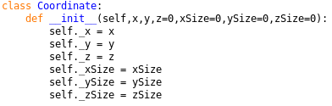
The object has 6 attributes, x,y,z,xSize,ySize,zSize which are all floats. X and Y are required, the others are optional and set to 0 per default. X,y,z are used as per the coordinate system described, and ?Size represents the size in that dimension using the unit in that dimension.

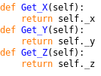
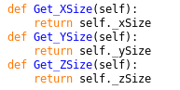
These functions obtain the relevant value and returns it.

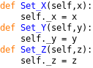

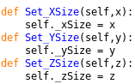
These functions are used to set the relevant value.

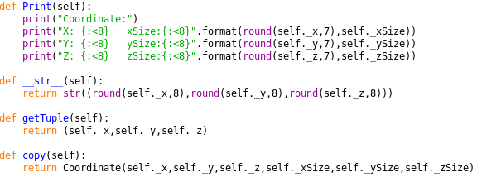
The print method is used to neatly display the coordinate, rounded to 7 significate figures and formatted into columns.
The __str__ method is used to override the default string method and returns a rounded representation when called i.e. used to convert coordinate to string. This does not contain the sizes as the general usage does not require the sizes.
The getTuple method returns a tuple containing the x,y,z coordinates in a tuple.
The copy method is used to duplicate the coordinate, returning a new coordinate with all the old coordinates details copied over.

General functions
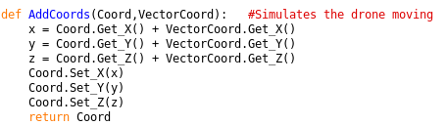
The AddCoords function is used to add two coordinates together , returning the original coordinate again. The function takes two coordinate objects, the second to be added to the first. The coordinates in each dimension are added and the first coordinate is set to these values.

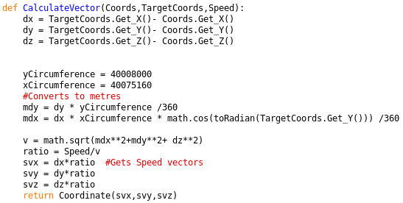
The function is used to calculate a movement vector for a drone travelling from one coordinate to another at a known speed. The program takes 3 variables, two coordinate objects and one float/ integer object speed. The difference between the target coordinate and coordinate currently at is calculated and stored. The Circumeferences variables contain the circumference of the earth in meters in that axis. The program then calculates the delta in x in meters , then the delta in y in meters taking into account that the earth is a sphere. The total velocity vector magnitude is calculate using pythagoras’ theorm in 3D and the ratio between vector magnitude and actual speed is calculated. This can be then used to calculate the speed vectors in the appropriate unit for each dimension, which is returned in a coordinate vector object.

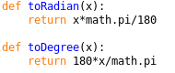
These functions return the input in radians / degrees respectively.

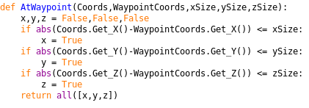
The AtWaypoint function is used to determine if a coordinate is within a certain range of the waypoint coordinate. The program takes two coordinate objects and three float/ integer values as parameters. The function sets the x,y,z variables to false, these mark if that dimension is within range. The program works out the absolute delta between the current and waypoint, if this is below the dimension limit size the dimension variable is set to true. Finally the program returns if it was close enough in each dimension or not using the all method.

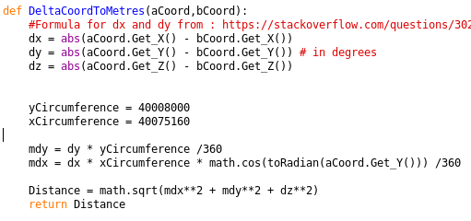
The DeltaCoordToMetres function is used to calculate the magnitude of the distance between the two different coordinates. The absolute distance is obtained for each dimension and stored. The Circumference variables are set to the values in each dimension. The delta in meters in y is calculated as well as that in x taking into account that the earth is a sphere.
Finally magnitude of the distance between the two points is calculated using pythagoras’ theorm.

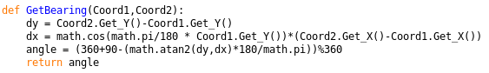
The GetBearing method is used to calculate the bearing from coord1 to coord2. This takes the delta for x and y with the x value accounting for the shape of the earth and calculates the angle. 360+90-angle is required to convert the angle system from mathamatical to the conventional N = 0 system. The modulus by 360 prevents angles above 360, wrapping round the values.

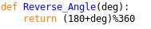
The Reverse_Angle method is used to reverse an angle (i.e. wind direction) by adding 180 (flipping) and modulus by 360 (return to the 0→ 360 range).

